Assignment 3 if for while conditions structure

Released Date: Oct 15th

Version 1.0

Format: Name the document in the combination of name、ID and No. of Assignment.

**Example: Ping Yi_23_Assignment1.doc**

**Email the document to “pingy@wxit.edu.cn” before Oct 18th.**

**Task 1** 4 LEDs are connected to Arduino Uno, try to use for cycle structure to make a 1s shift effect.

任务1 使用4个LED连接至Arduino Uno，尝试使用for循环结构，实现1s位移点亮的效果。

**You could use Tinker CAD or Proteus for the verifying.可使用在线工具Tinker CAD或Proteus进行仿真。**

**Answer1:**

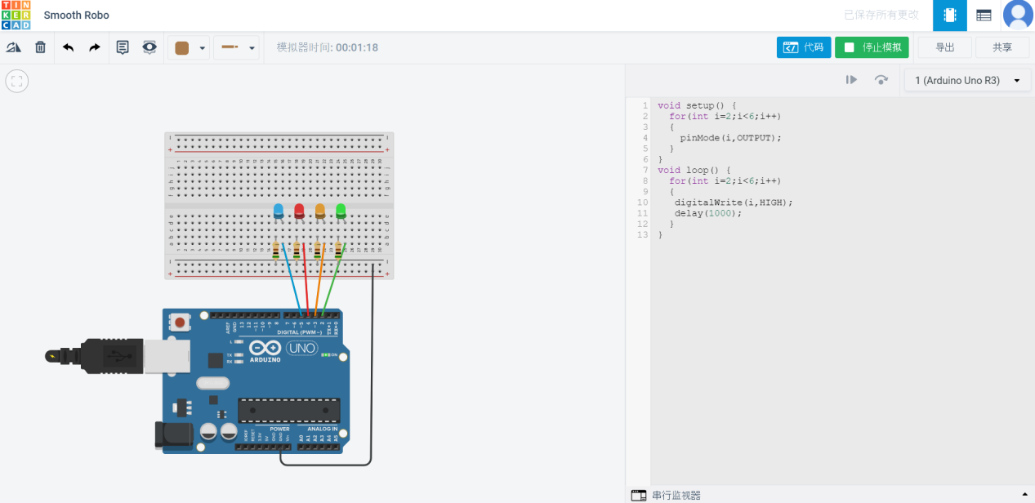

**void setup() {**

**for(int i=2;i<6;i++)**

**{**

**pinMode(i,OUTPUT);**

**}**

**}**

**void loop() {**

**for(int i=2;i<6;i++)**

**{**

**digitalWrite(i,HIGH);**

**delay(1000);**

**}**

**}**

**Task 2** One LED and a POT are connected to Arduino, define a function named getVoltage to calculate the real time voltage of the POT, if the value is larger than 2.5V, then turn on the LED.

任务2 一个LED和一个电位器与Arduino Uno相连，定义一个函数名为getVoltage，用于计算POT段子的实时电压，若电压大于2.5V，则点亮LED。

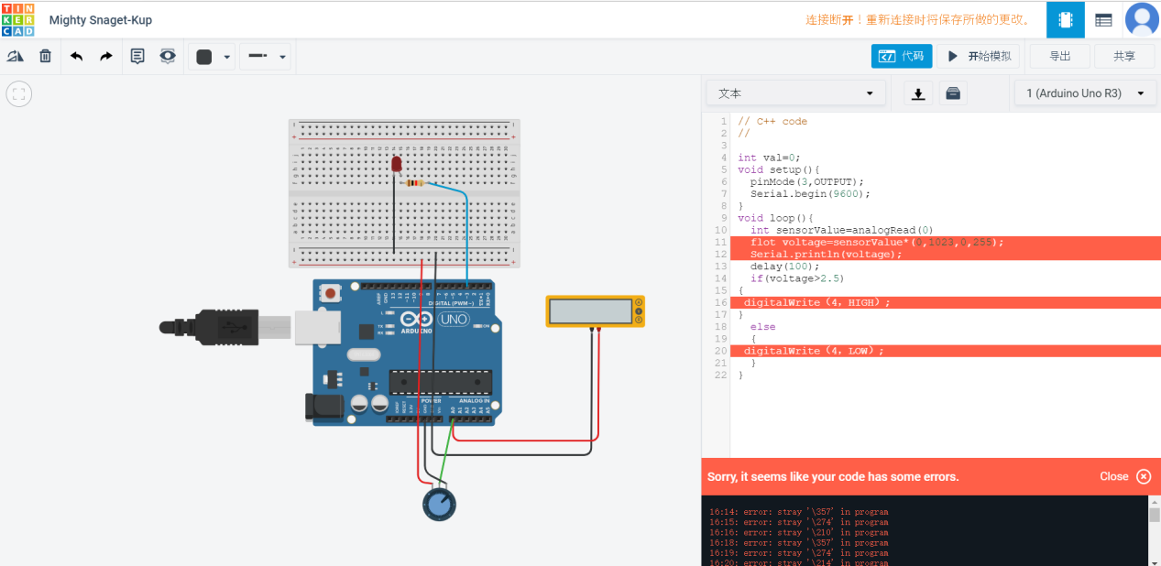

// C++ code

//

int val=0;

void setup(){

pinMode(3,OUTPUT);

Serial.begin(9600);

}

void loop(){

int sensorValue=analogRead(0)

flot voltage=sensorValue*(0,1023,0,255);

Serial.println(voltage);

delay(100);

if(voltage>2.5)

{

digitalWrite（4，HIGH）;

}

else

{

digitalWrite（4，LOW）;

}

}